Part 1
- Name the star in our solar system.
- How many planets in our solar system?
- What is the difference between a moon and a dwarf planet?
- What do we call the natural satellites in the solar system?
- Name the galaxy our solar system is part of.
- How was the sun formed, and what caused this to happen?
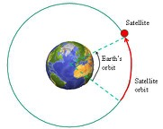
- List the major bodies found in the solar system.
- The international space station takes 92 mins to orbit the Earth. The Moon takes 27.3 days to orbit the Earth. Explain why these orbital times are different.

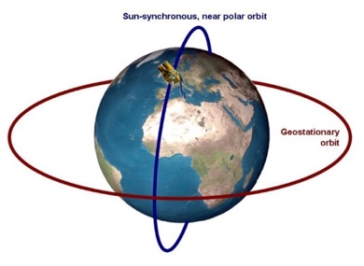
- The diagram shows a satellite orbiting the Earth. Explain how the Earth’s gravity can result in the satellites velocity changing but not its speed.

Part 2
- What does the diagram suggest is happening to the Universe over time?
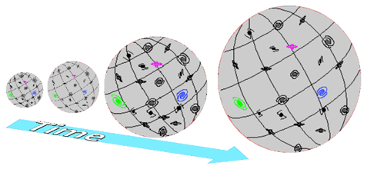
- Describe the current theory of how the Universe began.

- Which colour of light has the longest wavelength?

- The diagram shows the spectrum of light from a star in our galaxy.
Copy the second box by adding the spectra you would expect from a star in a distant galaxy.

- The light reaching Earth from distant galaxies exhibits red shift. Explain why red shift occurs.



Galaxy A Galaxy B
- If galaxy A has a much bigger red shift than galaxy B, what does this tell you about galaxy A?
- Which theory about the origin of the Universe does red shift of galaxies support?
- Approximately how many years ago did the Universe begin? (Circle the correct answer)
14 million 14 billion 14 trillion
- The most distant galaxies in the Universe are thought to be:
(tick the correct box)

The biggest galaxies Accelerating

Slowing down The coldest

- What is a nebula?

- What determines the life cycle a star will take?

- Describe the lifecycle of a star the size of the sun.

- Describe the lifecycle of a star more massive than the sun.

- What processes produce all of the naturally occurring elements?

- Where are elements heavier than iron produced?

- How are these elements distributed throughout the universe?

